Combining a Pre-Test and Post-Test to Create a SCORM-Compliant Assessment: Multiple Questions per Topic

Introduction
As an eLearning developer I’ve been tasked with creating courses for learners with different levels of experience in the subject matter being taught; and creating compliance courses meant to be taken on a yearly basis. In both cases a pre-test to determine which learning objectives the learner already knows, and does not need to be taught, would save training time and learner frustration.
This document will show you how to use a pre-test to inform the learner, what content they still need to learn, and which questions are presented in the post-test. This document also describes how to combine both tests into a single SCORM compliant assessment.
This design requires a pre-test, some content slides, and a post-test. The design assumes that all test questions are mapped to a specific learning objective in the course and that more than one question is required to cover the learning objectives in a given topic. The design also assumes that the course content can be viewed in any order.

The Variables
In this example there are six learning objective questions, two per topic. In this design you’ll need the following variables.
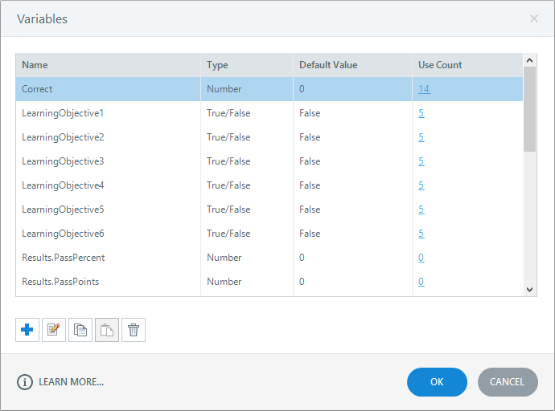
Six variables (LearningObjective*) to track whether a given pre-test question was answered correctly. These variables are initially set to False.
Three variables (Topic*Complete) to track whether the last page in a given topic has been viewed. These variables are initially set to False.
A variable (Correct) to track how many pre-test questions were answered correctly. This variable is set to 0.
* In this example the asterisk signifies a number 1-6 for the learning objective variables and 1-3 for topic complete variables.

The Pre-Test
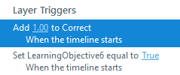
When a question is answered correctly, two variables are modified, using triggers in the Correct Answer Layer.
- The correct answer counter variable (Correct) is incremented by 1.
- The question variable (LearningObjective*) is set to True.
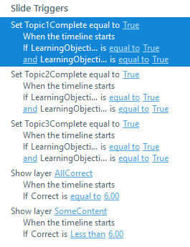
In this design, a course topic is considered to have been completed when the learner correctly answers all the questions tied to the learning objectives for that topic. When a topic is ‘complete’ the button for that topic on the Main Menu will still be active, but set to the state Visited.
The final slide of the pre-test contains a trigger that sets the topic variable (Topic*Complete) if all the (LearningObjective*) variables related to that topic are set to True. In this example there are three topics.
The final slide of the pretest also has two layers that contain, information on how many questions were answered correctly, and buttons that lead either to the Main Menu or the final Results slide.

- Layer SomeCorrect is displayed if the learner answered any question incorrectly.
- Layer AllCorrect is displayed of the learner answered all the questions correctly.
The value of the counter variable (Correct) determines which layer is displayed. The value for (Correct) is also used to indicate the number of questions answered correctly, as you can see in the examples below.
If the learner answers all the questions in the pre-test correctly, they skip the content and post-test, and go directly to the Results slide.
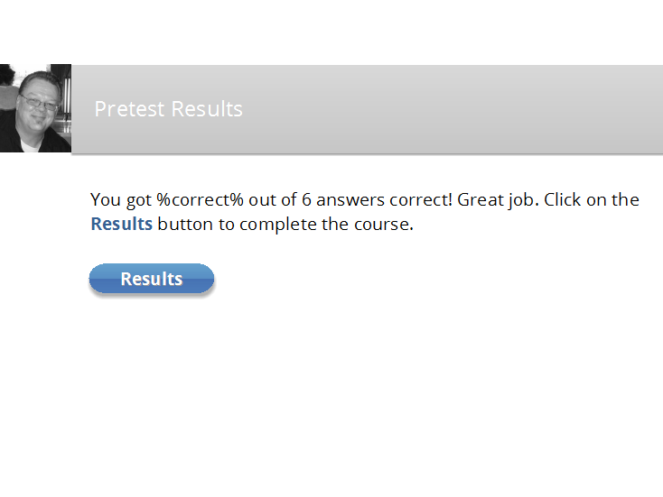
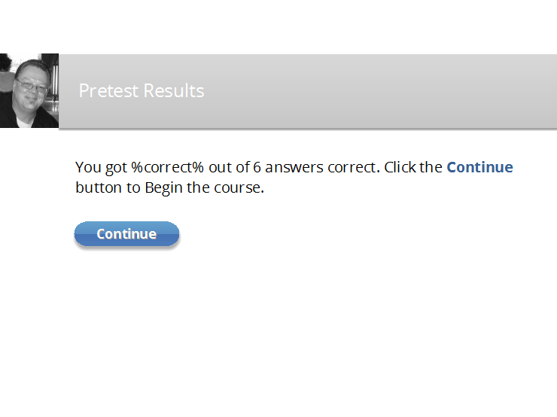

The Main Menu
The Main Menu contains a button for each topic. The buttons for topics, where the topic viewed variable (Topic*Complete) is True, are set to the visited State, which in this example is light grey with white text.
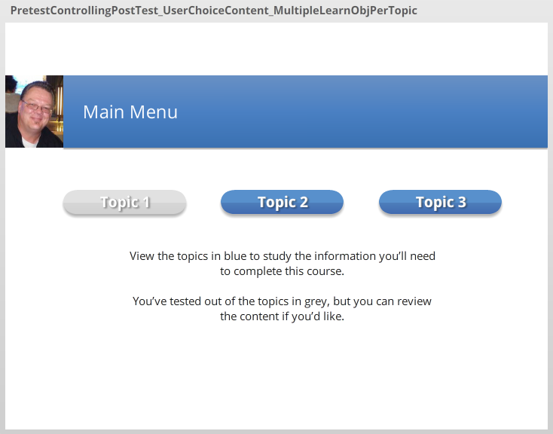
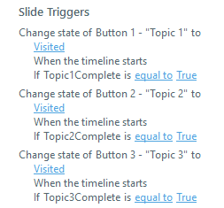

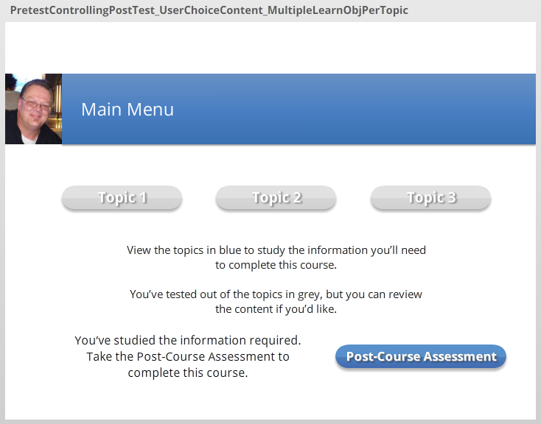
When all topics are complete, and each (Topic*Complete) variable set to True, a layer with a button to access the post-test is displayed.

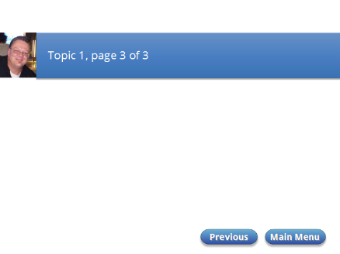
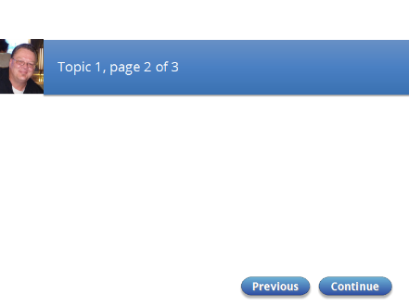
The Topic Slides
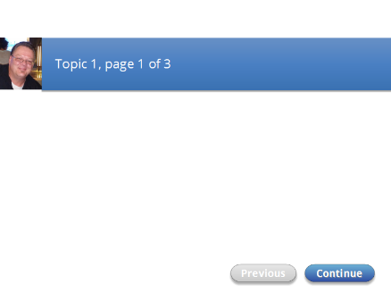
On the final page the topic variable (Topic*Complete) is set to True.

The Post-test
In this design, the post-test only displays the questions the learner answered incorrectly in the pre-test.
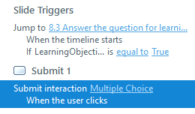
A Slide trigger in each question tells Storyline to jump to the next question if the question/topic variable (LearningObjective*) is set to True. In other words, if the learner answered that question correctly in the pre-test, they won’t see that question again in the post-test.
After the final question, the learner is taken to the Results slide.

The Pre-test and Post-test Form a SCORM Compliant Course Assessment
In this example you want the learner to pass the course if he or she answers six test questions, mapped to the six learning objectives, correctly.
In this design the learner has two chances at each question. He or she can answer it correctly in the pre-test, or answer a matching question correctly in the post-test. Due to the limitations of Storyline you cannot use the same question slides for both the pre-test and post-test. You need two separate, but identical, tests.
Here are some factors to consider when you combine a pre-test and post-test into a single assessment:
- Though the learner sees only six unique questions, there are actually twelve total questions, six in the pre-test and six matching questions in the post-test.
- The final Results slide includes the six question from the pre-test and the six questions from the post-test
- The learner can only answer a question correctly once. If they answer a question correctly in the pre-test, variables tell Storyline to skip the matching question in the post-test.
- Questions not viewed in the post-test are considered by Storyline to be incorrect.
- If the learner answers a question incorrectly in the pre-test, they will be given a chance to answer the matching question in the post-test.
- In this design the highest possible score for a SCORM compliant course assessment that combines the pre-test and post-test is 50%.

Let’s looks at a few examples where the passing threshold is 50%, which requires that the learner answer all the unique questions correctly.
In example one, the learner answers all six unique questions in the pre-test correctly. With a combined score of 50%, the learner passes the course.
Pre-test | Result | Post-test | Result | Combined
Question 1 | Correct | Not shown | Storyline considers Incorrect
Question 2 | Correct | Not shown | Storyline considers Incorrect
Question 3 | Correct | Not shown | Storyline considers Incorrect
Question 4 | Correct | Not shown | Storyline considers Incorrect
Question 5 | Correct | Not shown | Storyline considers Incorrect
Question 6 | Correct | Not shown | Storyline considers Incorrect
Percentage Correct | 6 of 6, or 100% |  | 0 of 6, or 0% | 6 of 12, or 50%

In example two, the learner answers all six unique questions correctly, three in the pre-test and the other three in the post-test. With a combined score of 50%, the learner passes the course.
Pre-test | Result | Post-test | Result | Combined
Question 1 | Correct | Not shown | Storyline considers Incorrect
Question 2 | Correct | Not shown | Storyline considers Incorrect
Question 3 | Correct | Not shown | Storyline considers Incorrect
Question 4 | Incorrect | Shown | Correct
Question 5 | Incorrect | Shown | Correct
Question 6 | Incorrect | Shown | Correct
Percentage Correct | 3 of 6, or 50% |  | 3 of 6, or 50% | 6 of 12, or 50%

In example three, the learner answers four of the six unique questions correctly, three in the pre-test and one in the post-test. With a combined score of 25%, the learner fails the course.
Pre-test | Result | Post-test | Result | Combined
Question 1 | Correct | Not shown | Storyline considers Incorrect
Question 2 | Correct | Not shown | Storyline considers Incorrect
Question 3 | Incorrect | Shown | Incorrect
Question 4 | Incorrect | Shown | Correct
Question 5 | Incorrect | Shown | Incorrect
Question 6 | Incorrect | Shown | Incorrect
Percentage Correct | 2 of 6, or 33% |  | 1 of 6, or 17% | 3 of 12, or 25%

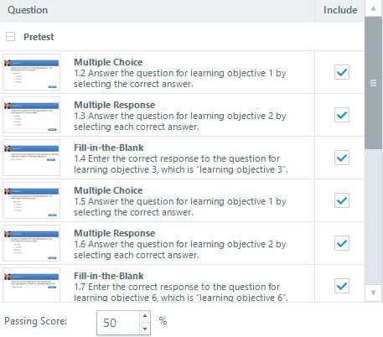
The Results Slide
In the post-test results slide, include only the questions from the pre-test and the post-test.
Set the Passing Score. The maximum score is 50%.
One potential issue will be that learners won’t consider 50% a good score, especially since in their mind they answered all the questions correctly.

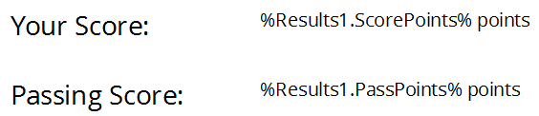
Here are two work-arounds to avoid this problem.
Remove the score percentage variables (Results1.ScorePercentent) and (Results1.PassPercent) from the Results slide, and only show the points scored variables.
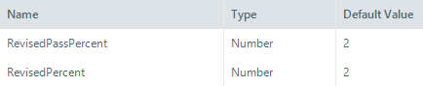
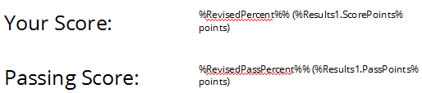
Another solution would be to replace the score percentage variable (Results1.ScorePercentent) with a new variable (RevisedPercent) and replace the passing score percentage variable (Results1.PassPercent) with a new variable (RevisedPassPercent).
Both new variables are the Number type and have initial values of 2.
Once the new variables are created, place a trigger in the Results slide that sets (RevisedPercent) to the value (RevisedPercent) x (Results1.ScorePercent). For a score of 50%, the result would be 2 x 50 = 100.
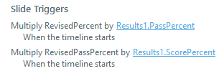
Place another trigger in the Results slide that sets (RevisedPassPercent) to the value (RevisedPassPercent) x (Results1.PassPercent). For a passing threshold of 50%, the result would be 2 x 50 = 100.

Conclusion
I’ve included all you need to know about creating a pre-test that determines what questions are presented in the post-test and how to combine these two tests together to form a SCORM compliant assessment. If you have any questions, drop me a line!

